Riphah International University
I-14 Campus Islamabad
Lab_Task_04
Department: Data Science
Subject: Data Structure
Submitted By:
Hammad Sajjad Awan
SAP ID:
76142
Submitted To:
Junaid Khan
Date Of Submission:
23-09-2026

Lab Report
Lab Activity 1:
Activity 1 — Linear Search and Binary Search
Create a Java program that performs both Linear Search and Binary Search on an array.
Use the following arrays:
Linear Search Array:
int[] linearArray = {45, 12, 78, 34, 23, 89, 56};
Binary Search Array:
int[] binaryArray = {12, 23, 34, 45, 56, 78, 89};
Ask the user to enter a target value to search for.
Part A — Linear Search
Implement a method:
linearSearch(int[] arr, int target)
The method should:
- Start from index 0.
- Compare each element with the target.
- Return the index if the target is found.
- Return -1 if the target is not found.
Part B — Binary Search
Implement a method:
binarySearch(int[] arr, int target)
The method should:
- Initialize low and high.
- Calculate the middle index.
- Compare the middle element with the target.
- Search the left or right half depending on the comparison.
- Return the index if the target is found.
- Return -1 if the target is not found.
Required Output
Display:
- Target value
- Result of Linear Search
- Result of Binary Search
- Index position of the element, if found
Also briefly identify why the Binary Search array must be sorted.
Solution:
Linear Search:
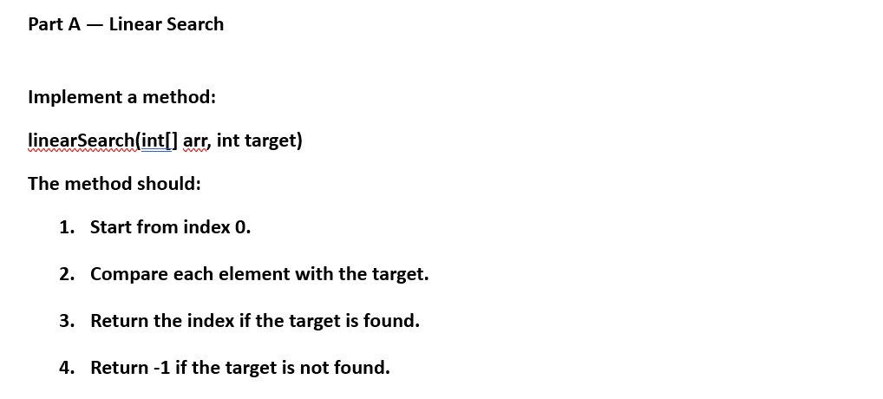
Answer:
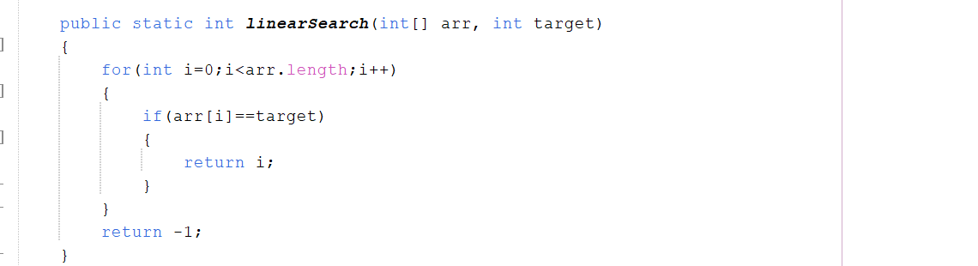
Binary Search:
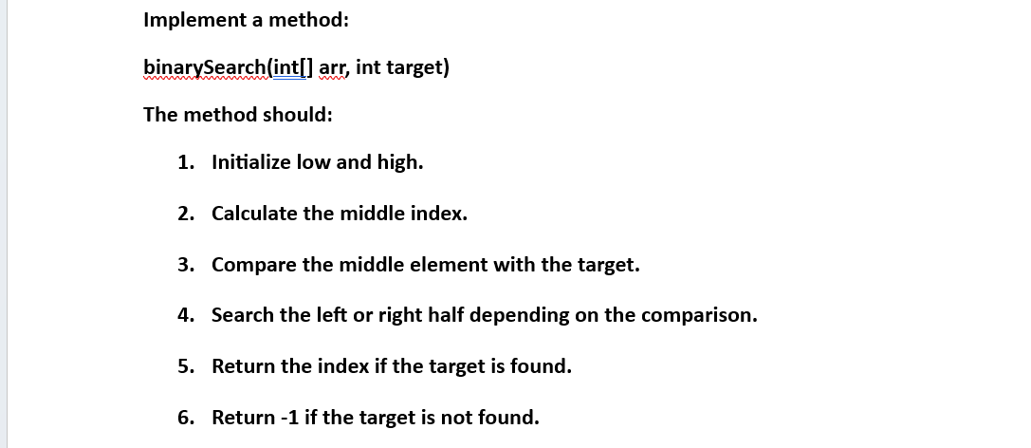
Answer:
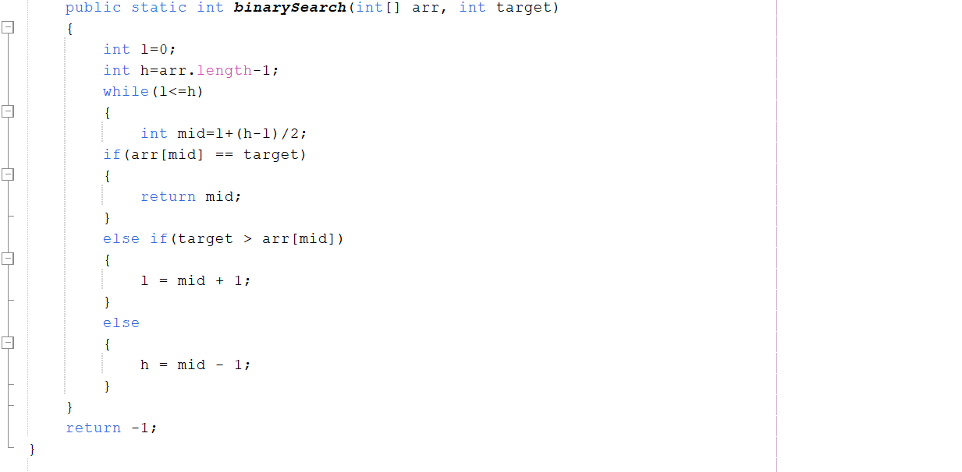
Required Output :
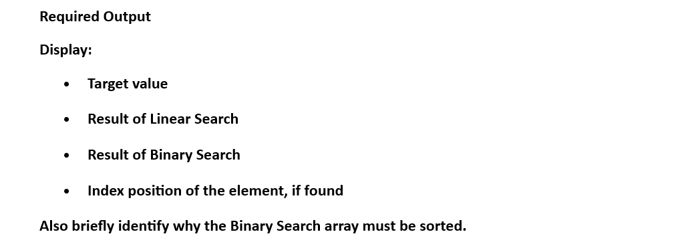
Answer:
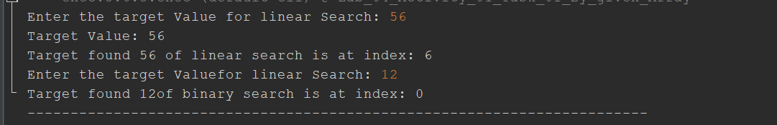
Complete Code:
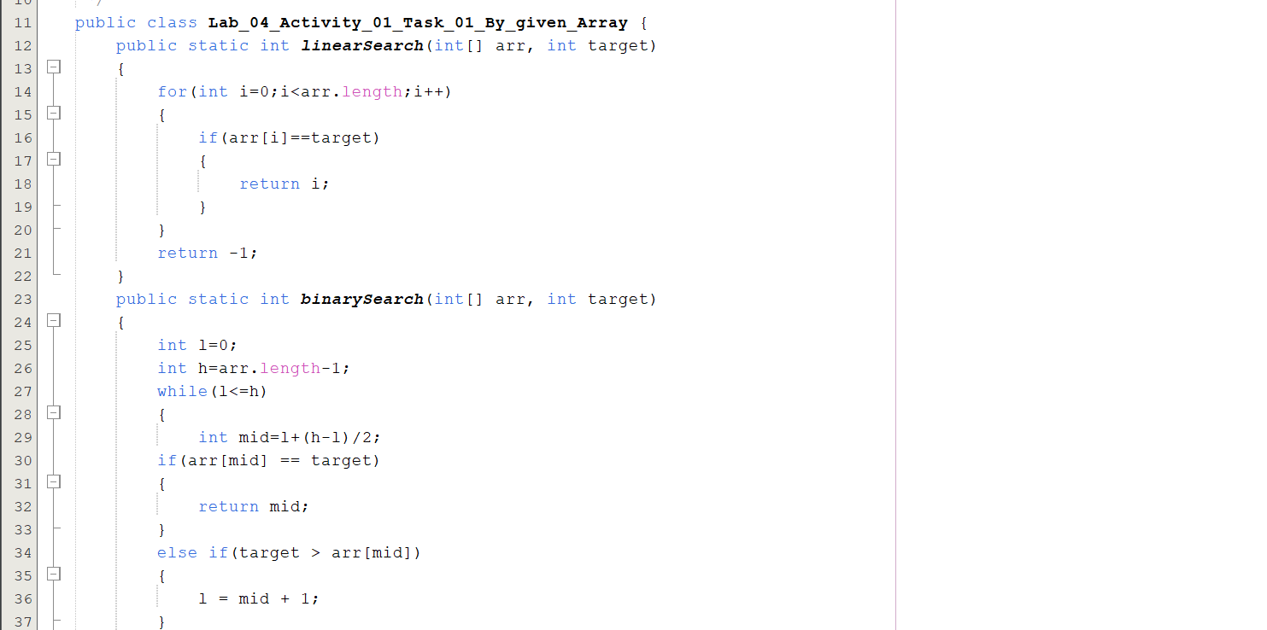
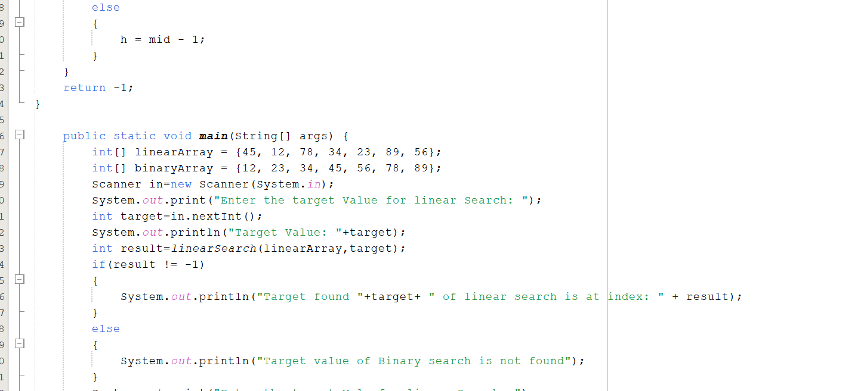
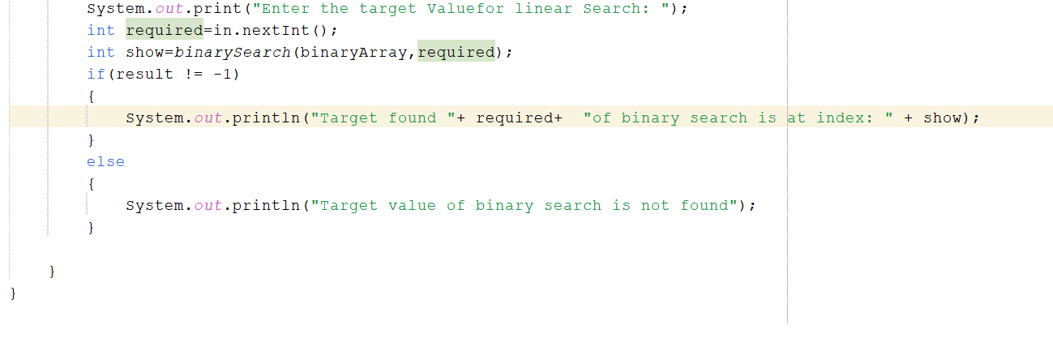
Output:
Question:
Also briefly identify why the Binary Search array must be sorted.
Answer:
Binary Search requires a sorted array because it compares the target with the middle element and uses the sorted order to eliminate half of the array from the search. Without sorting, it cannot determine which half contains the target.
=============================================
Lab Activity 2:
Activity 2 — Stack Operations
Implement a Stack using an array without using Java's built-in Stack class.
The Stack should have a fixed capacity of 5 elements.
Implement the following methods:
push(int value)
pop()
peek()
display()
Required Operations
Your program should demonstrate:
- Push — Insert an element onto the top of the Stack.
- Pop — Remove the top element.
- Peek — Display the top element without removing it.
- Display — Display all elements currently present in the Stack.
- Detect Stack Overflow when the Stack is full.
- Detect Stack Underflow when attempting to remove an element from an empty Stack.

Demonstration
Perform the following sequence:
Push 10
Push 20
Push 30
Display
Peek
Pop
Display
Solution:
push(int value)
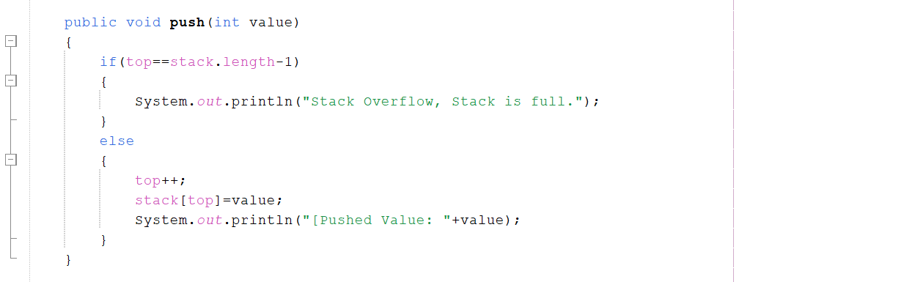
pop()
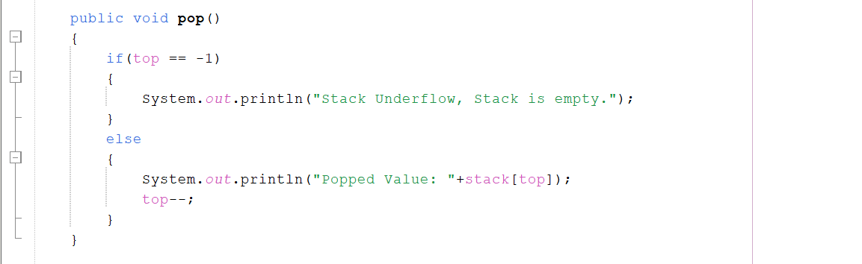
peek()
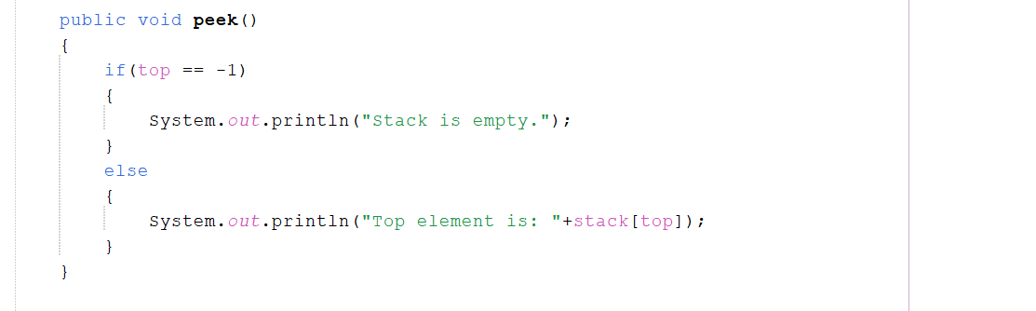
display()
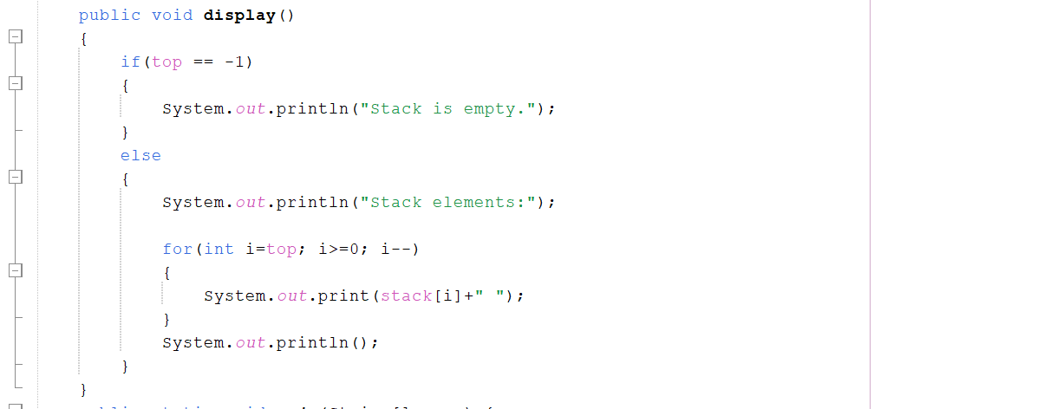
Operations:

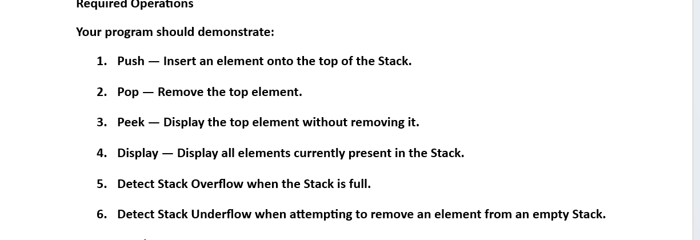
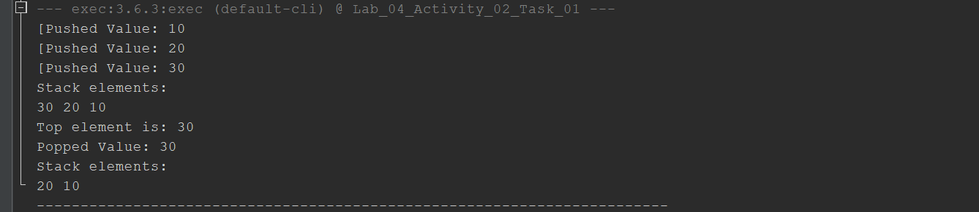
Output:
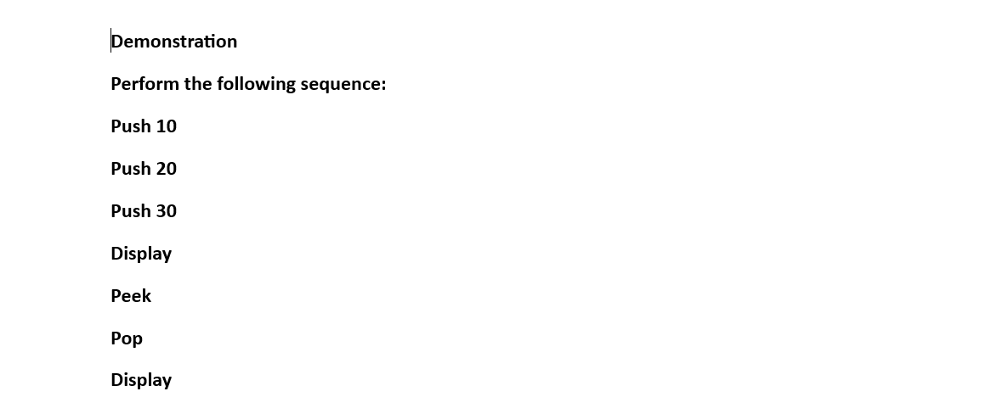
Answer:
Complete Code:
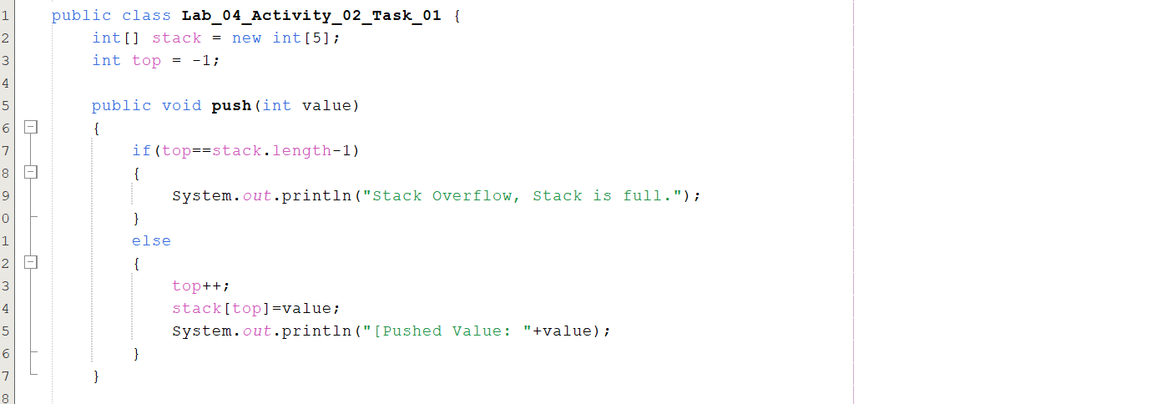
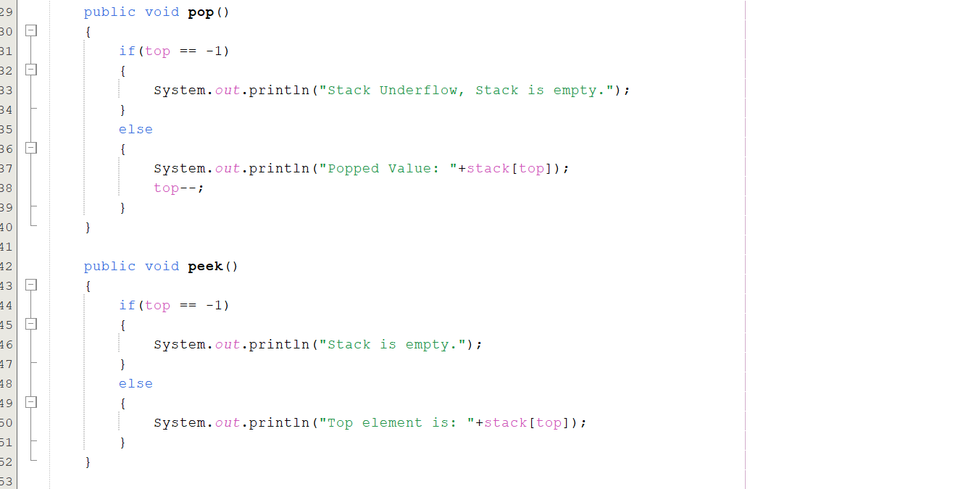
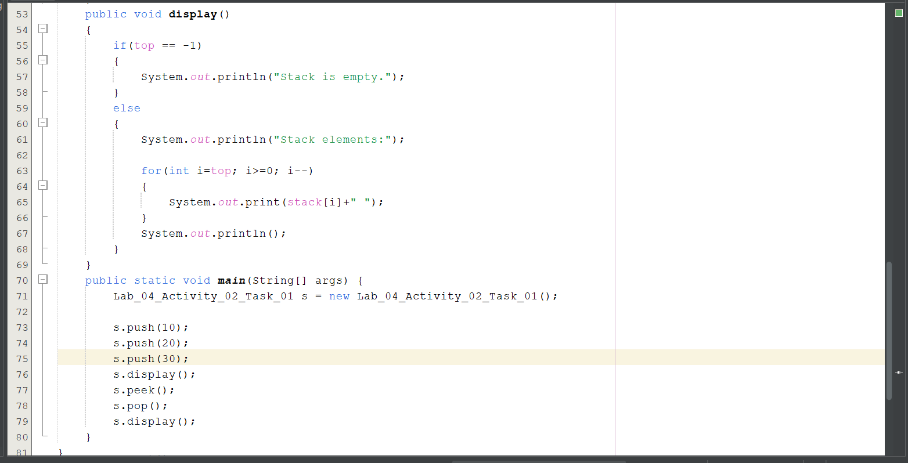
Answer:
=============================================
Lab Activity 3:
Activity 3 — Queue Operations
Implement a Queue using an array without using Java's built-in Queue class.
The Queue should have a fixed capacity of 5 elements.
Implement the following methods:
enqueue(int value)
dequeue()
peek()
display()
Required Operations
Your program should demonstrate:
- Enqueue — Insert an element at the rear of the Queue.
- Dequeue — Remove an element from the front of the Queue.
- Peek — Display the front element without removing it.
- Display — Display all elements currently present in the Queue.
- Detect Queue Overflow when the Queue is full.
- Detect Queue Underflow when attempting to remove an element from an empty Queue.
Demonstration
Perform the following sequence:
Enqueue 10
Enqueue 20
Enqueue 30
Display
Peek
Dequeue
Display
Solution:
enqueue(int value)
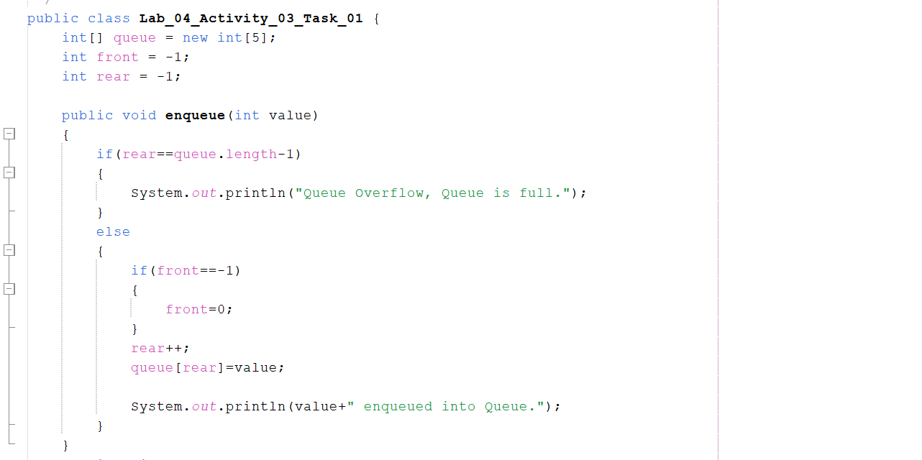
dequeue()
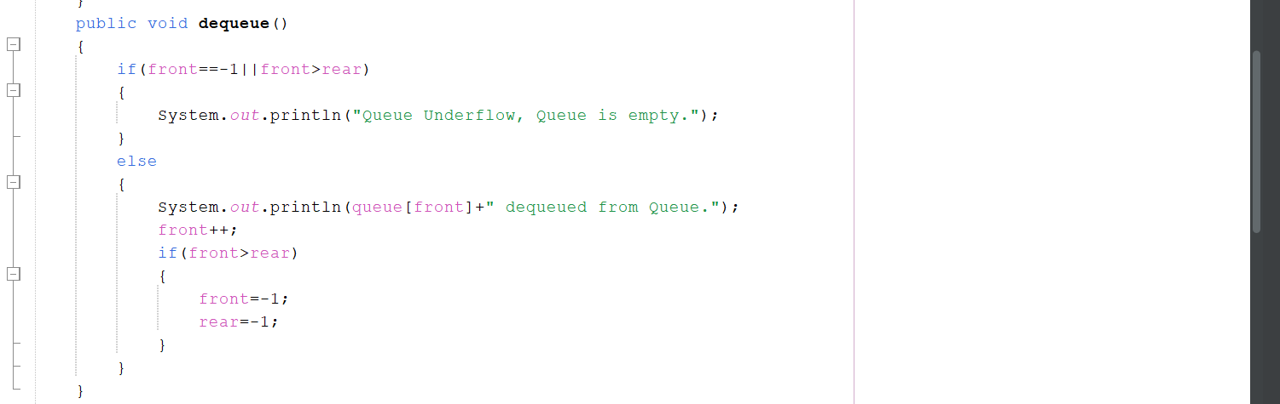
peek()
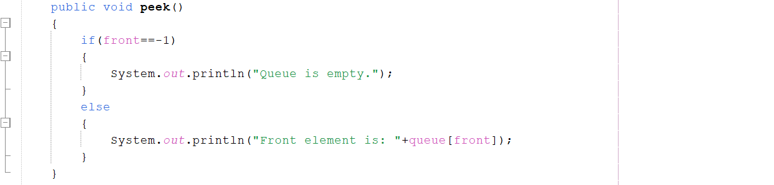
display()
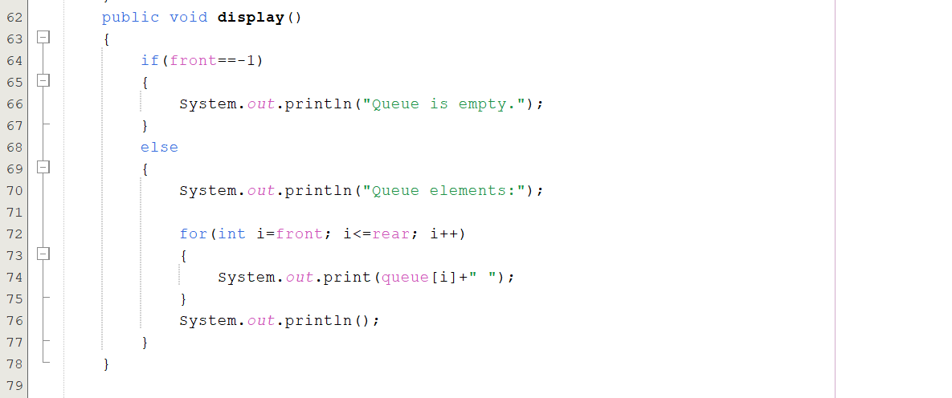
Operations:
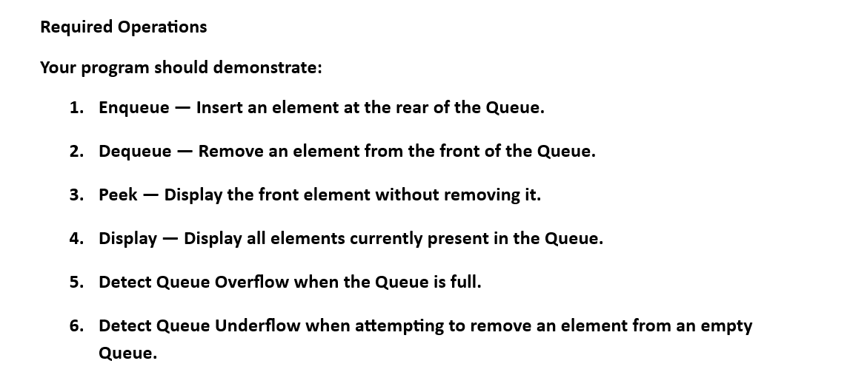
Answer:
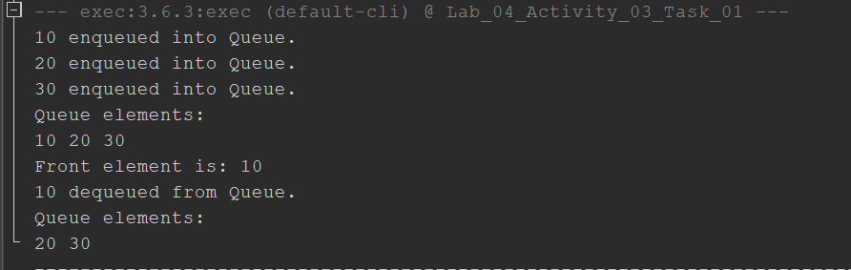
Output:
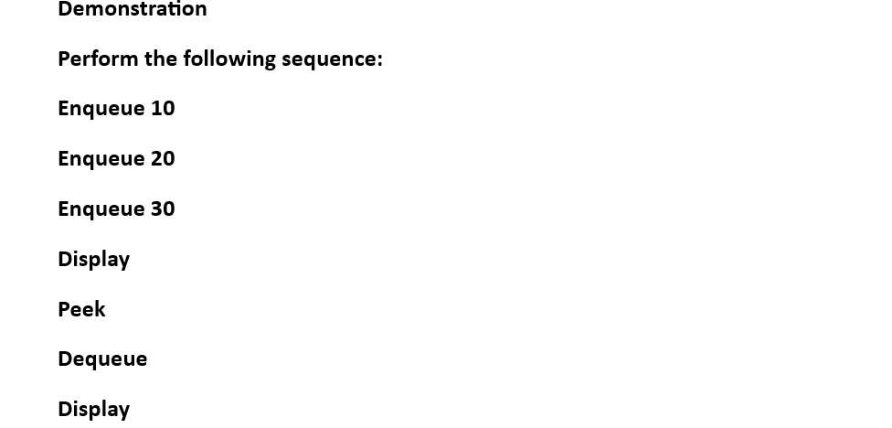
Answer:
Complete Code:
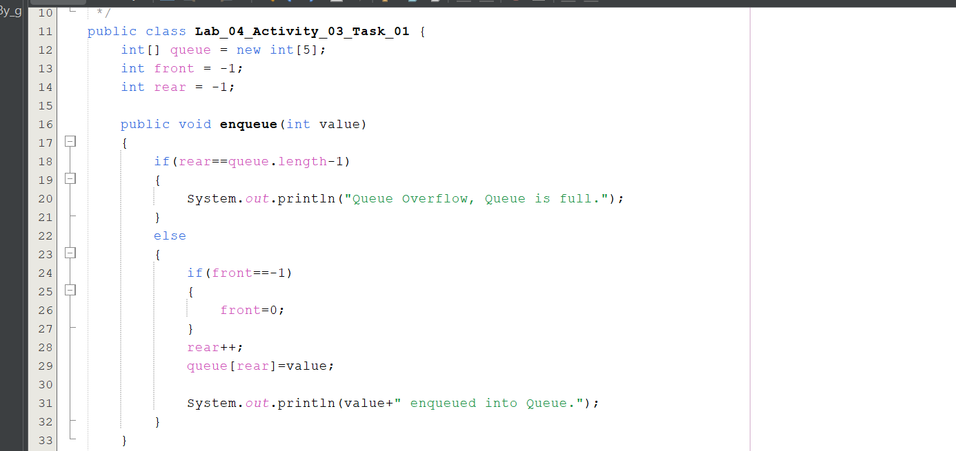
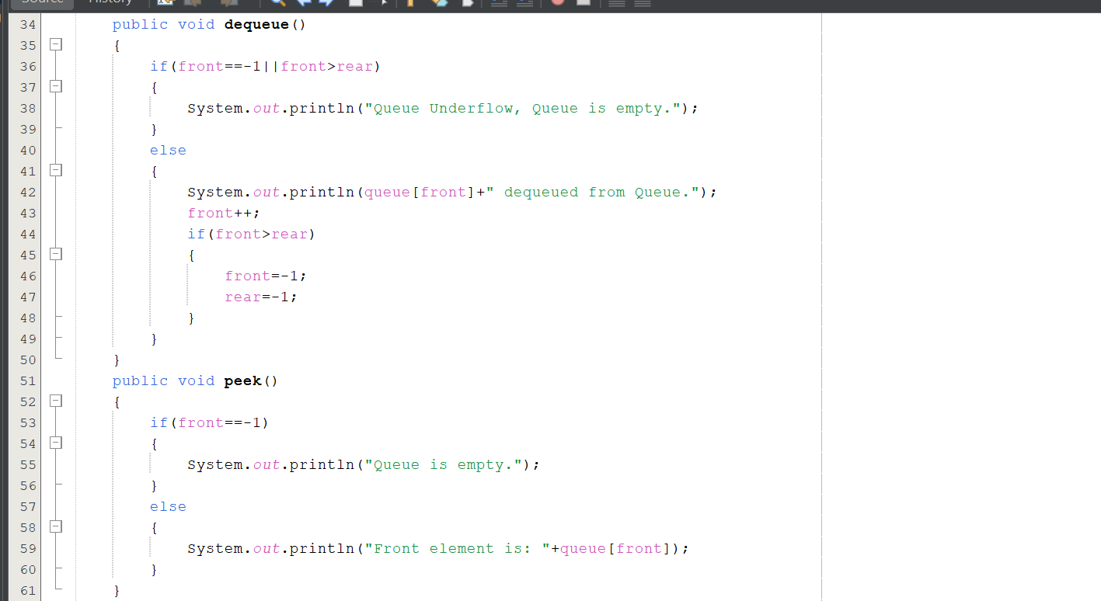
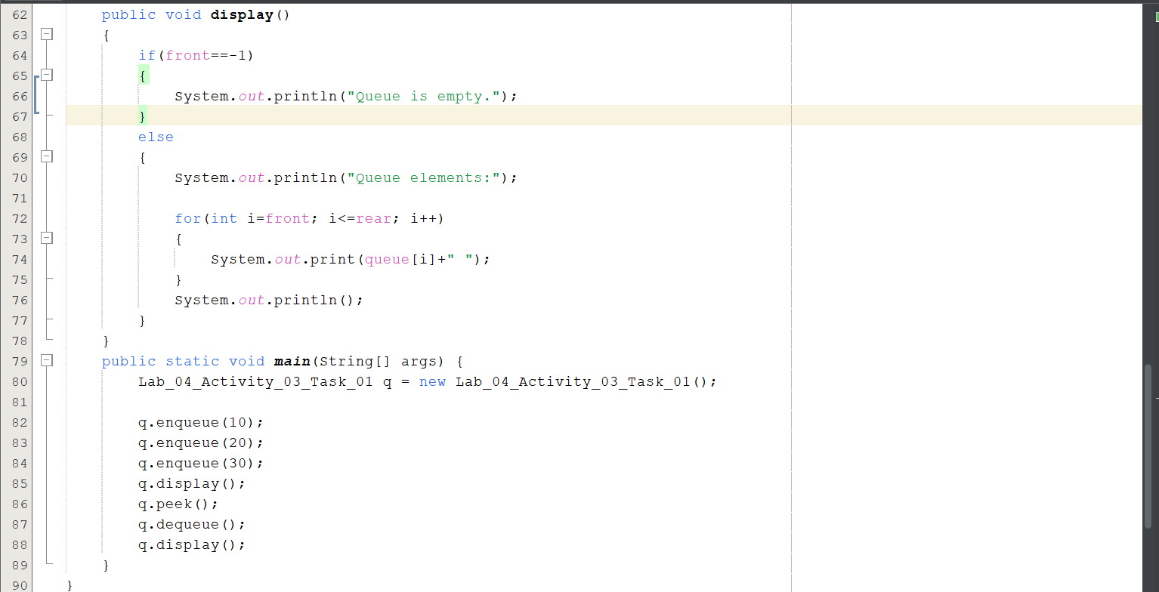
Answer:

End

